Arkansas Antenna
When I lived in St Louis, MO my main antenna for the Ham station was a Mosley TA-33-M, tri-band Yagi, beam. It is a very good antenna with lots of gain and a good front-to-back ratio. The specs for this antenna can be found at the following web address.
http://www.mosley-electronics.com/pages/amateur/ta33m.htm
Here is a picture from right after she was first installed. Keep in mind this antenna has a turning radius of 15.5 ft. That means the distance from the tip of the back element to the opposite tip of the front element was 31 feet. It is a beast!
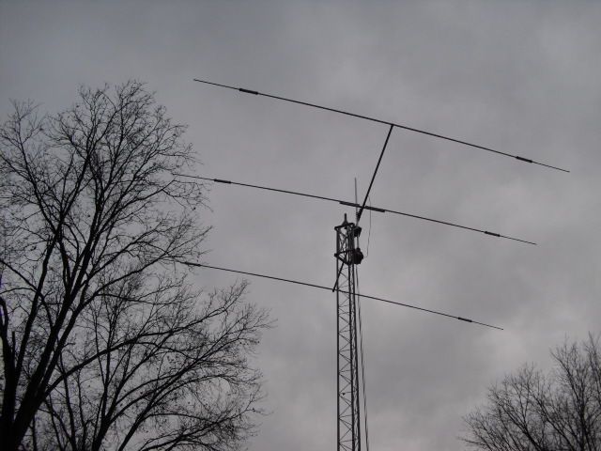
Notice the middle element was a little crooked. I lowered the antenna and fixed this right after the picture was taken. The tower in the picture is 40 feet tall. No guy wires because it was bolted to the side of the house 10 ft above the ground. It would withstand a 100 mph wind no problem.
When we moved to Arkansas I took the antenna, tower and all the equipment down as I was planning to install it at the new house in Hot Springs Village. But, we ran into a bit of a problem.
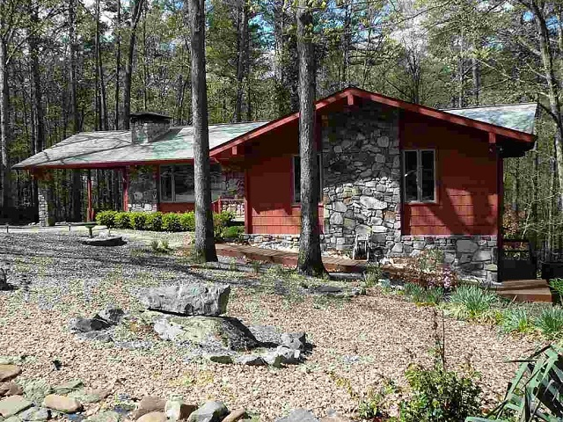
Just look at all those beautiful trees! Mother Nature’s organic ham radio towers. Uh, but wait, have you ever heard of too much of a good thing? There was no way I was going to be able to install a tower and that beast of an antenna with the 31 foot wingspan in this place without some serious tree work.
Okay, so I added that to the growing list of things that General Anne said must be done before the house was up to snuff. She had a few small things she wanted to do like paint the inside of the house. I couldn’t argue there because the previous owner painted the kitchen bright PINK! It was like being inside a bottle of Pepto-Bismol.
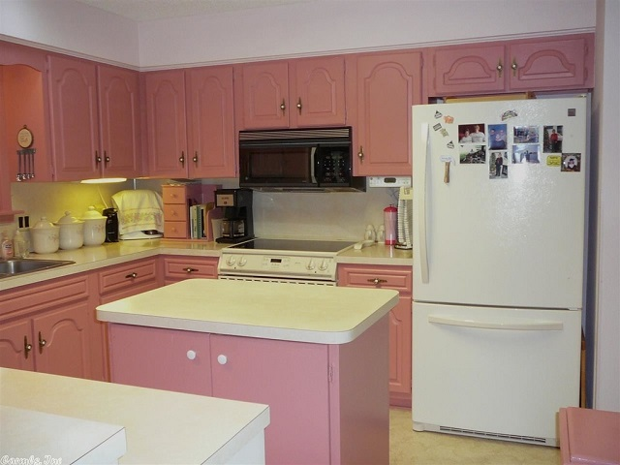
She wanted to paint the interior of the house because it was not the right color. When I asked what color she wanted and she said white, (the interior was white) she politely informed me it was the “WRONG” shade of white. Well, I’ve been married to this lady for over 30 years and learned a long time ago that it is sometimes best to just say, “Yes Dear”. This was not a big deal because I am pretty good with interior painting. I have been a home owner for over 30 years and interior paint is not expensive.
She also insisted the exterior of the house needed to be painted a color other than that “barn-red” color. Well we discussed it thoroughly and inspected the paint on the exterior of the house. We discovered it was a mess. It was peeling in several places and would need to be stripped before repainting it.
So we called the neighbor lady who just happened to be a house painter by profession. She turned out to be a great friend and a really tough old bird (the painter lady, not the Mrs.). She gave us a cost plus 10% bid which was extremely low for the work that needed to be done and laughed when I almost choked at the price. Then she said, “Don’t panic because I wouldn’t paint this house if I were you. Instead you should see about getting new siding on the exterior. You can get it in almost any color you want, including pink.”
Then she busted up laughing at the expression on my face. She gave us a couple of siding companies to contact and we contracted one of them to do the siding job. I am amazed at what that siding cost. OUCH.
The next thing on her list was rebuilding the back patio deck. It was old, discolored and bug-eaten. I was afraid it would collapse every time I had to walk on it. So we contacted a local guy who builds decks and invited him over to give us an estimate. Well, he looked it over and gave me a break on the price if we would provide him and his 2 man crew with lunch during the three days it would take to demolish the old deck, remove it and build the new deck. He also had some great ideas on how to build the new deck and keep it within the property line. The old deck was 7 inches too far into the property line to the south.
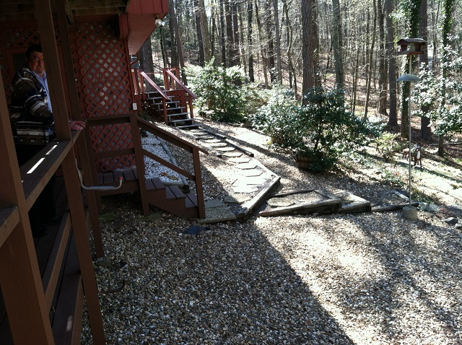
You can see part of the old deck steps leading down to the walkway cement steps above.

So, what does all this have to do with the antenna? It’s called budget. Those were the things I had to get finished before I could start working on building the new tower and antenna system.
Yup, you guessed it. By the time we got finished with all the “General” improvements there was very little budget money left to do the antenna. But there WAS some left.
So I started pricing the tree work that needed to be done. Let’s see, there were about 9 trees that had to be removed from the back yard to make room for that beast of an antenna. The first tree service I contacted gave me a bid that was ridiculously expensive. $2000 per tree to cut them down and all the branches that would land in the yard when the trees came down, then to grind the stumps. I laughed after I waved good-bye to him thinking ‘he must think I just fell out of one of those trees and landed on my head’. Then I called another guy who was much more reasonable but still was way too expensive to fit into my budget.
Man! I may never get this antenna back in the air. So, I decided to sleep on it for a few days. They turned into a few weeks. Then one night it suddenly dawned on me to follow my own advice and start thinking outside the box. I remembered there is a tripod type of tower that I could mount on the roof.
It is manufactured by Glenn Martin Company and cost a LOT less than cutting down those trees. It is designed to be installed on top of your roof. This takes advantage of the height of the roof and would almost get the antenna to the desired height above ground. Actually, because the lot our house sits on is slanted down-hill toward the back of the house it would actually work as well as a 40 foot tall tower in the back yard, and there are no trees growing on top of the roof.
Next I went outside and scoped out the roof to see if any tree limbs would interfere with rotating the antenna. Yup, there were a few but nothing as severe as removing the trees. However, that is still a beast of an antenna and I was concerned about all the limbs that would have to be trimmed.
I called the tree guy back again and got another quite to just trim the branches and was astounded at the price again. He wanted $2900 just to trim the branches. He said that was the minimum size job he would handle. I’ll admit there were a LOT of them. But I was pretty sure I was on the right track with the roof mounted tower so I contacted GlennMartin and ordered their 8 ft tall, tripod, roof-mount, tower with the lag-bolt kit to install it. The link below is to the one I got and includes the tower specs. Notice it will handle up to 85 mph winds with 10.5 sq ft of wind loading. It would handle that Mosley beast antenna just fine with lots of room to spare.
http://www.glenmartin.com/rt-832-8%e2%80%b2-roof-top-tower/

But, I was still outside of my budget when you added in the trimming tree limbs. So I started looking around again. I really love that Mosley antenna. It served me very well for 4 years in St Louis. I was able to contact any station I could hear with if only it was a little smaller I would not need to trim all those tree limbs overhanging the roof.
Smaller? Then I remembered seeing a Mosley mini-beam on their web site. It was still a 3 element Yagi antenna but did not have that huge wingspan of 31 feet. It only has a 10.4 foot turning radius. That is a 21 foot wingspan. That will work. It also has close to the same forward gain (only 1 db less) as the bigger antenna and is lighter which will make it much easier to install on the tripod tower. Mosley gave me a great discount for customer loyalty. I bought several repair parts from them for the beast TA-33 beam when I got her used from another ham.
Here is a link to the Mosley Mini-33-A, mini-beam antenna I ordered.
http://www.mosley-electronics.com/pdf/amateur/mini33a.pdf
I would show you a picture of it but it has not arrived here yet. It is due to ship on March 14th this month. Now we’re cookin’.
So then it was time to also get some cable for my old reliable Alliance HD-73 rotator. This required a trip to Lowes Hardware store where I picked up 50 feet of 6 conductor cable. I didn’t really like the cable because it was solid wire instead of stranded but it was a little bigger than the required minimum 18 GA and was on sale for only $20 so I bought a roll of it.
When I got it home I hooked it up to the rotator and the control box here in the shop. Guess what? It didn’t work. I could get it to rotate but the sensing potentiometer in the rotator bell housing had gone bad. It would only display about half of the rotation then the indicator on the control box would go off scale. I took that thing apart several times trying to find the right adjustment for it but could not get it to work.
So, after re-greasing myself and the rotator several times while taking it apart and putting it back together, I called a friend who does rotator repairs. He had me run some tests with my VOM to make sure I had it connected properly and listened politely as I described the symptoms while rotating it on the bench. Then he gave me the bad news. The 75 ohm metal sensor potentiometer had gone bye-bye. No replacements available of the right size etc. So, unless I could find a parts only HD-73 with a good pot in it I was out of luck. He offered to sell me a replacement HD-73 but by the time shipping was added in it would cost almost as much as a new one.
So I told him thanks and went back to searching for an inexpensive rotator that would handle the 2.5 sq ft of the new antenna I had on order. I found one from the most unlikely company. Yaesu has a line of rotators that includes one that will fit the bill nicely. Their G-450A rotator would work with plenty of room to spare. Yaesu has a different way of measuring the wind load and rotator capacity. So I ran it through my calculator and found that it will do the job with plenty of extra capacity. It will handle up to about 10 sq ft of antenna and mast as long as I install it inside the tower and not on top of a pole. Even on top of a pole it will handle the light loading of the new Mosley antenna and 2 inch diameter mast. They call it the K-factor which takes into account the wind loading of the antenna and the mast and the weight of both. And here is the best part. The cost on sale (thanks RandL Electronics) was $375 including shipping.
When, I am back in line with the budget again. I won’t have to eat beans and rice for supper for the next two years.
The rotator and the rotator cable, plus 100 ft of new Coax ($100 shipped) from the Wireman arrived and I couldn’t wait to get it all put together and tested. I love the smell of a smoking soldering pencil in the evening LOL.
Okay, I got the rotator cable connectors installed on the ends of the rotator cable. I did notice something I thought was a little strange in the instructions with the rotator. They told you to solder the connectors on one end of the cable but not the other. It said to just crimp them on. That didn’t sound quite right to me but I followed the instructions anyway. Also, their pictures of which wire goes where were confusing to me at 10:30 pm in the shop after getting up at 6am that morning. Anyway I plugged it all up and it didn’t work. The lights came on in the control box like the directions said to expect. But it would not rotate. I gave up and went to bed.
The next morning I went back down to the shop and started trouble shooting. Everything looked good except I had two of the wires crossed (insert appropriate excuse here). It was on the connector end of the cable where they said to just crimp the wires then push the pins into the connector. Hmm, I started trying to push the two wires out of the Molex connector and the wires came off the pins for those two plus two others. Now I knew I was right and should have soldered them. However, it made it a lot easier to get the tiny pins out of the connector body. It was time to go through the gyrations of soldering those tiny pins to the ends of the HUGE wires. Well, they seemed huge when looking at them through the magnifying glass.
It was time for the big test again but this time I ohmed out the cable from end to end and everything was in the right place. I connected it all up again to the rotator and the control box and turned it on. Yup, the lights came on again just like the first time. But, this time when I hit the rotate button it MOVED! I yelled, “IT’S ALIVE” and General Anne called me on the intercom and asked if I was okay LOL.

So, I ran the rotator through all the diagnostics and alignments required in the instructions and it passed everything perfectly. The needle pointer on the control box was only about 2 degrees off so I corrected that by following the instructions and it came out perfect. This is a nice little rotator. It will turn 450 degrees. That is 90 degrees past one full revolution.
So, that, my friends, is how I spent $1500 on a brand new antenna system that cost less than putting up the old one I still have on hand.
I hope you enjoy reading this little story. It is all true. My point in telling you this is that it is almost always better to think outside the box when you get stumped on a project and have trouble determining what to do next. Give it a little time and a lot of thought and the right answers will come to you.
Oh yes, by the way. The tree limb trimming guy will be here next Wednesday to trim the trees. I still have to get the guys out here to re-enforce the attic rafters for the new tower. When they are finished I will still be a little under budget with enough left over to take General Anne out to dinner.
73 and stay safe
DE K7RMJ Frank

