Four States QRP Club Receiver ZZRX-40
Part-1
The mailman was really good to me yesterday (12/21/2016). Look what he brought me.
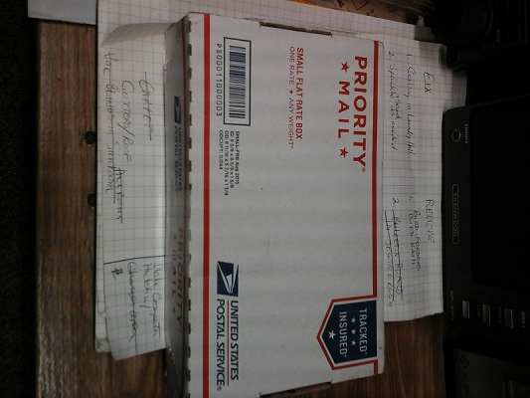
First though, I think I better clean up the workbench a little.
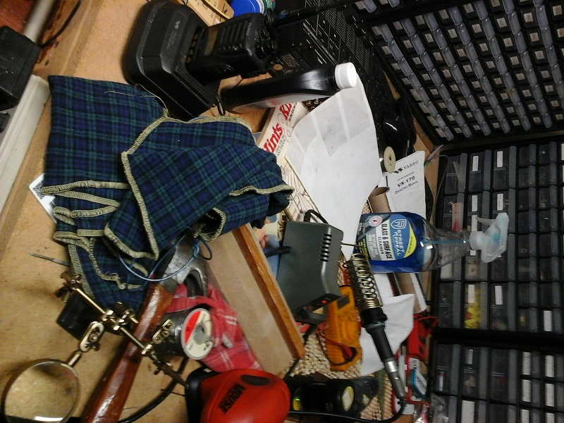

Okay, this is a little better. I am told that a clean bench is the sign if a sick mind.
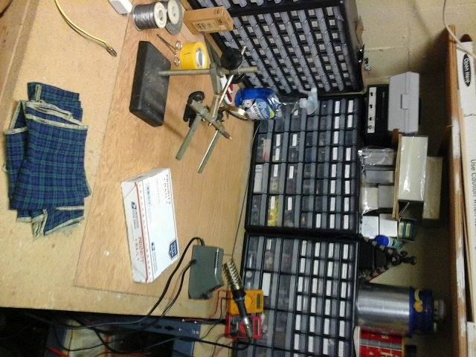

The 4SQRP Club is offering a little 40 meter receiver for sale for only $45 plus shipping. I couldn’t resist. It will make a great match to my little CatsCan-3 transmitter.
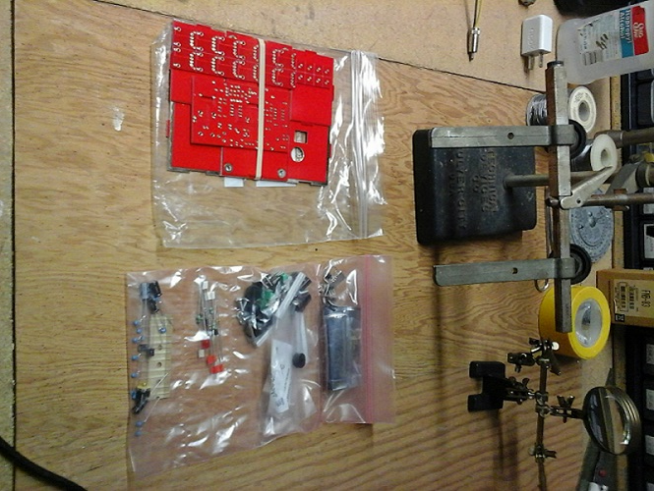

I tore up the shipping box pretty badly when opening it and I like to use a box to organize the parts in. So I glued parts of the box back together and used it. You can use the edges of the box to hold you parts that have long leads on them and label them on the box. This cuts down the confusion factor significantly. The other parts, such as the jacks, panel mount parts and other hardware can rest in the bottom of the box. It keeps them out of the way and less likely to jump off the workbench and run across the room. Don’t ask how I know this.
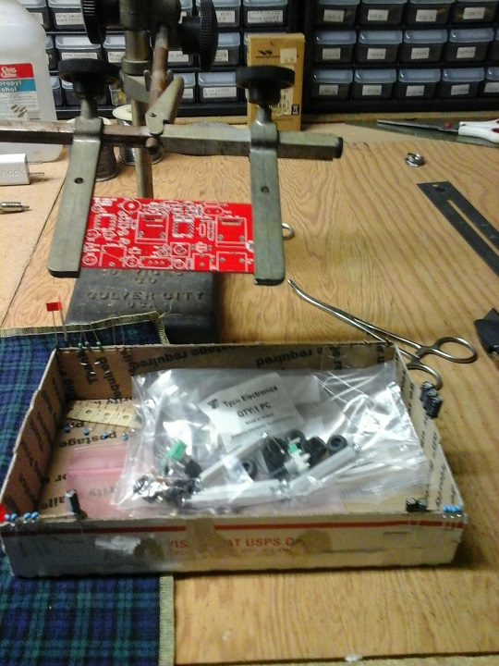
That funny looking gizmo above the box in the picture is a circuit board vice. It allows you to turn the board over, lift it up, and adjust the board for the best position needed to work on it. I got this years ago at a ham-fest back when I lived in California in the late 1980’s and 90’s. Other tools I have out on the bench for kit building are the soldering station with adjustable temperature and a very fine pointed tip, a magnifying glass because my old eyes aren’t quite as good as the used to be and an assortment of small wire cutters and needle nose pliers.
Stay tuned for part-2. Not sure when I will post it because it is very close to Christmas and the ‘Honey-do’ list the wife handed me this afternoon will take more time than I had planned LOL.

Regards,
Frank Shears DE K7RMJ

